VPC-CHALLENGES
- Design and deploy a scalable network architecture using AWS Transit
Gateway to simplify network connectivity between multiple VPCs.

- VPC Setup Overview
VPC Name | CIDR | Region
my-vpc-01 | 172.168.0.0/24 | Europe (Stockholm)
vpc-2 | 10.0.0.0/28 | Europe (Stockholm)
vpc-3 | 10.0.1.0/28 | Europe (Stockholm)
vpc-4 | 10.0.2.0/28 | Europe (Stockholm)

- Create Subnets in Each VPC
Example:
VPC | Subnet CIDR
my-vpc-01 | 172.168.0.0/26
vpc-2 | 10.0.0.0/28
vpc-3 | 10.0.1.0/28
vpc-4 | 10.0.2.0/28
Each subnet must be Available and auto-assign IPv4 turned ON if public.
- Launch EC2 Instances (1 per VPC)
Instance Name | VPC | Private IP Example
vpc-1-ec2 | my-vpc-01 | 172.168.0.6
vpc-2-ec2 | vpc-2 | 10.0.0.12
vpc-3-ec2 | vpc-3 | 10.0.1.46
vpc-4-ec2 | vpc-4 | 10.0.2.13
All in running state
Allow SSH with your key pair

- Create Transit Gateway (TGW)
VPC Console → Transit Gateways → Create TGW

- Create TGW Attachments for Each VPC
Transit gateway attachments → Create attachment
Attachment Name | VPC
vpc-1-tga | my-vpc-01
vpc-2-tga | vpc-2
vpc-3-tga | vpc-3
vpc-4-tga | vpc-4
State shows Available
- Update Route Tables in Each VPC
Example Routing (for vpc-2 route table)
Destination | Target
10.0.0.0/28 | local
10.0.1.0/28 | Transit Gateway
10.0.2.0/28 | Transit Gateway
172.168.0.0/24 | Transit Gateway
Repeat same logic:
Routing summary
VPC | Needs route to | Target
my-vpc-01 | All 10.0.x.x CIDRs | TGW
vpc-2 | 172.168.0.0/24 & other 10.x | TGW
vpc-3 | 172.168.0.0/24 & other 10.x | TGW
vpc-4 | 172.168.0.0/24 & other 10.x | TGW
Save routes on all VPC route tables
- Modify Security Groups
Edit inbound rules to allow internal network:
Type | Port | Source
All Traffic | All | 172.168.0.0/16
All Traffic | All | 10.0.0.0/24
This allows ping/SSH inside the TGW network
- Connectivity Test Between VPCs
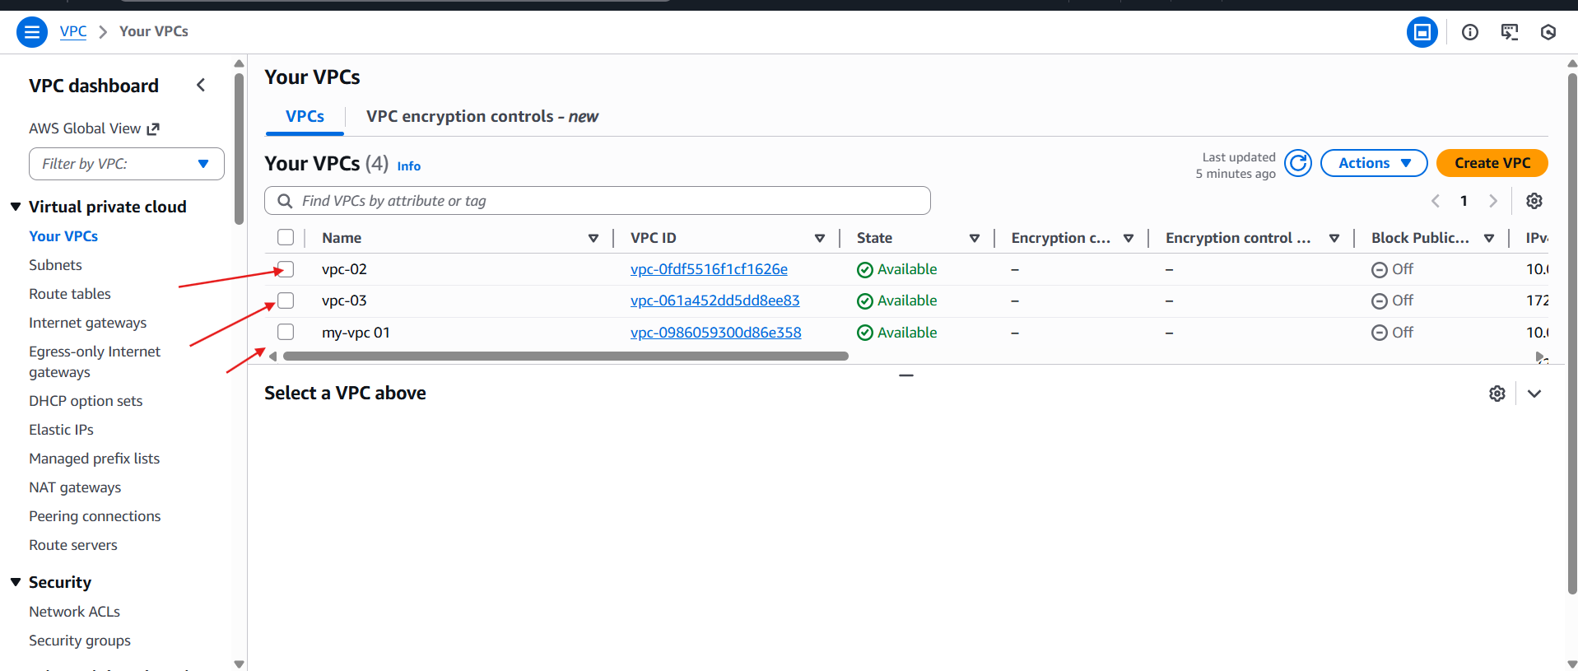
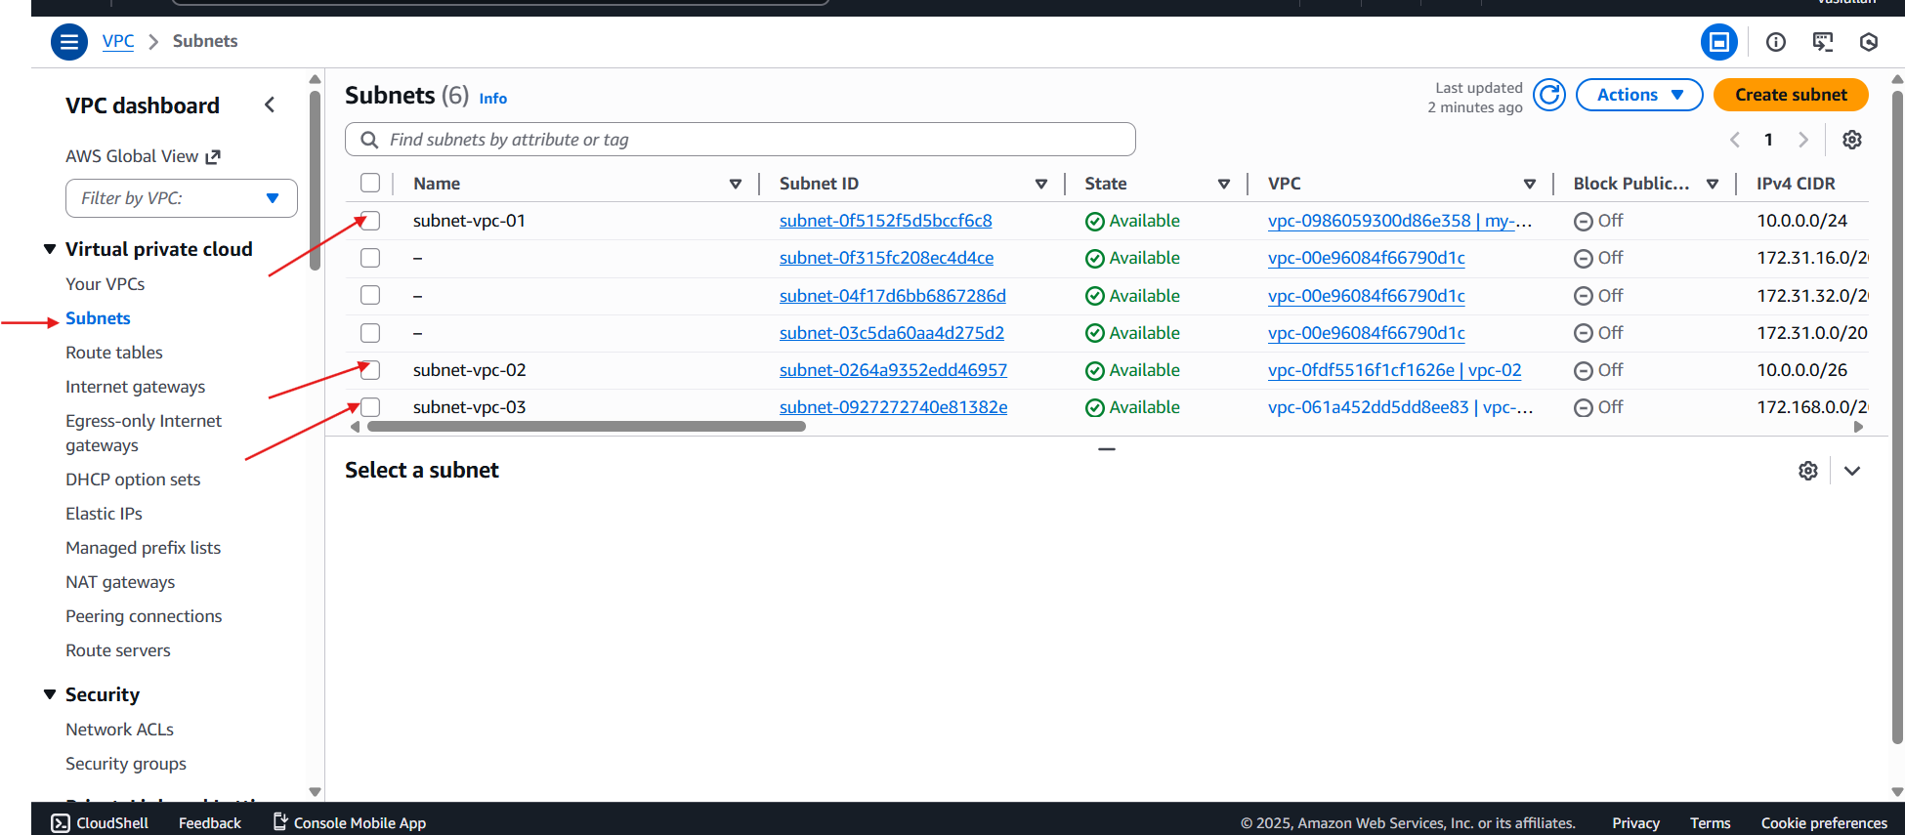
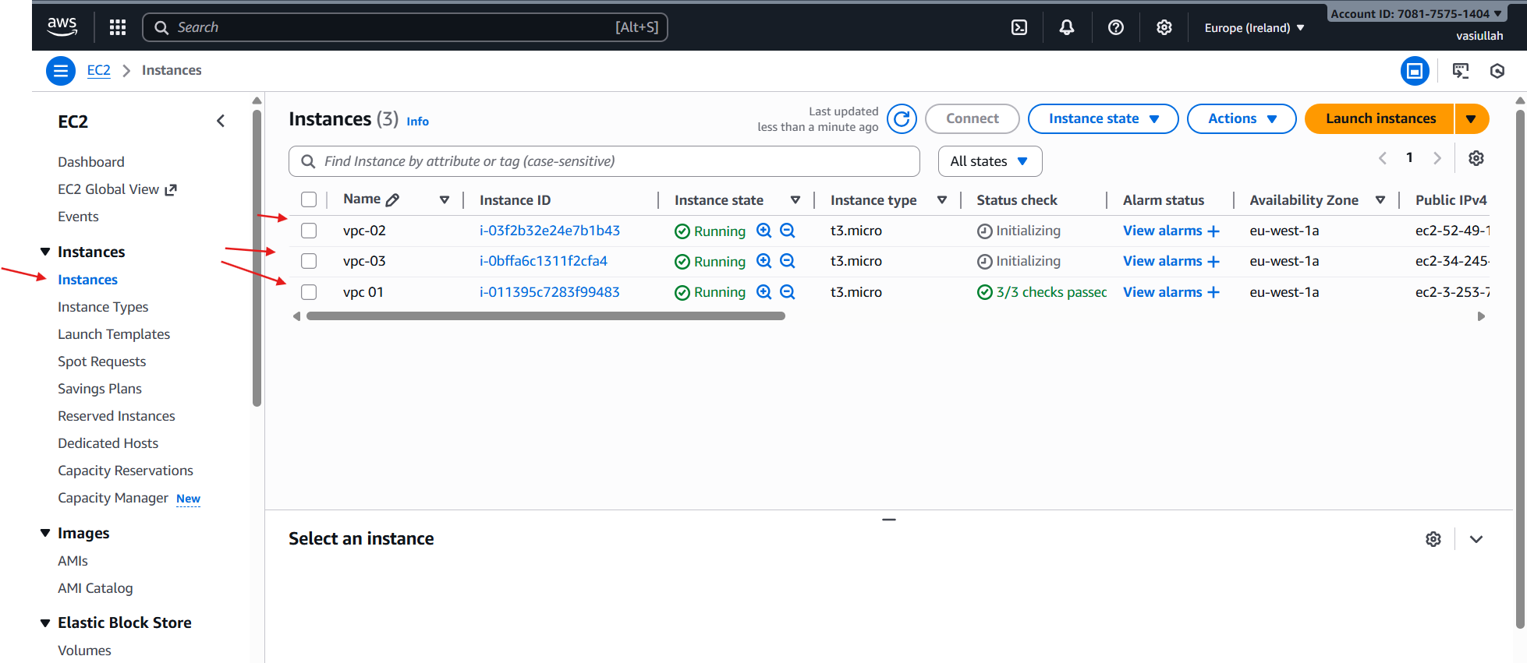
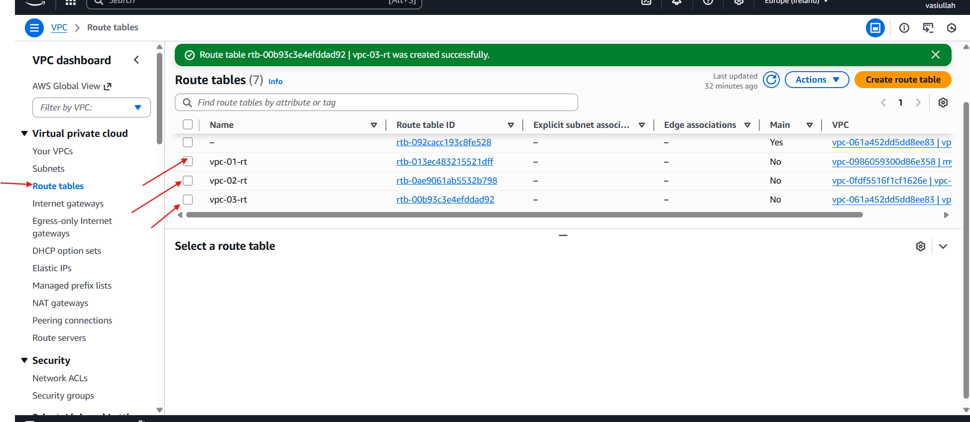
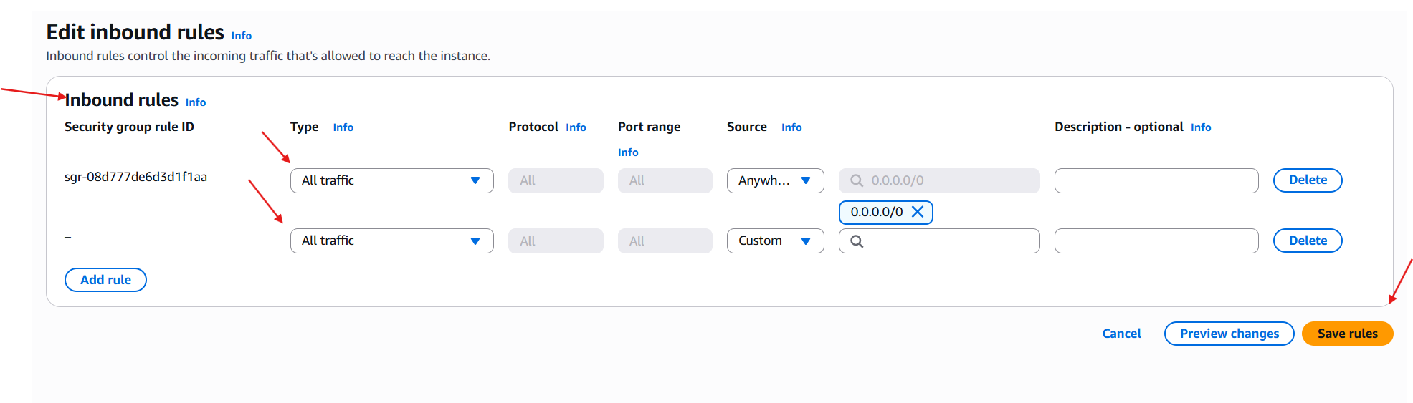
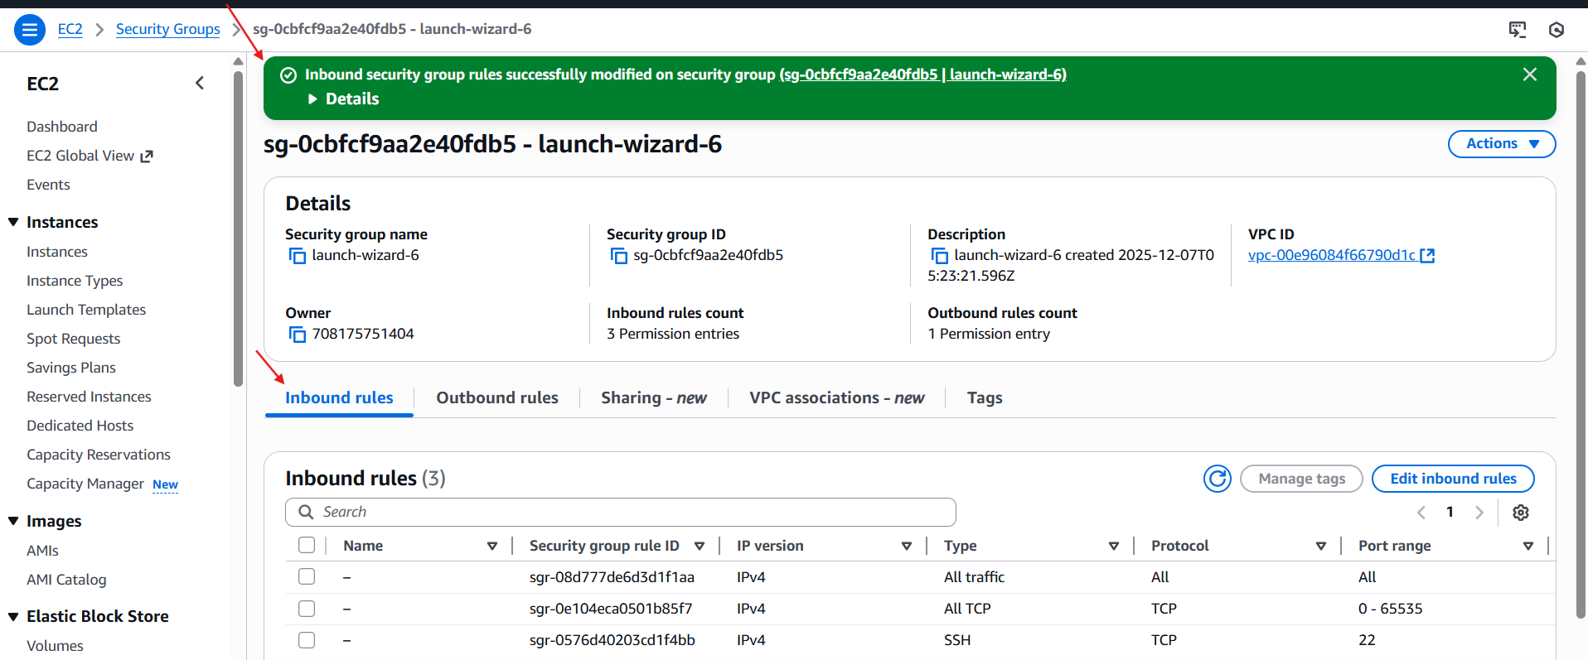
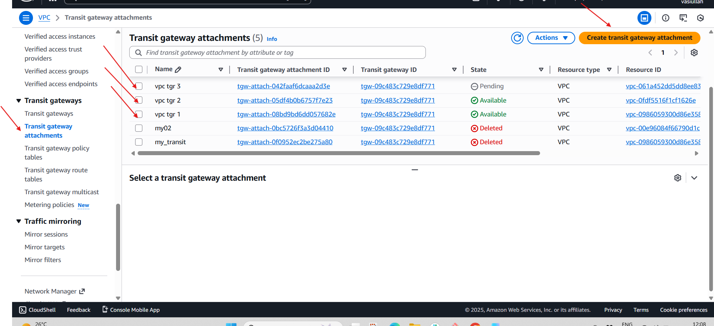
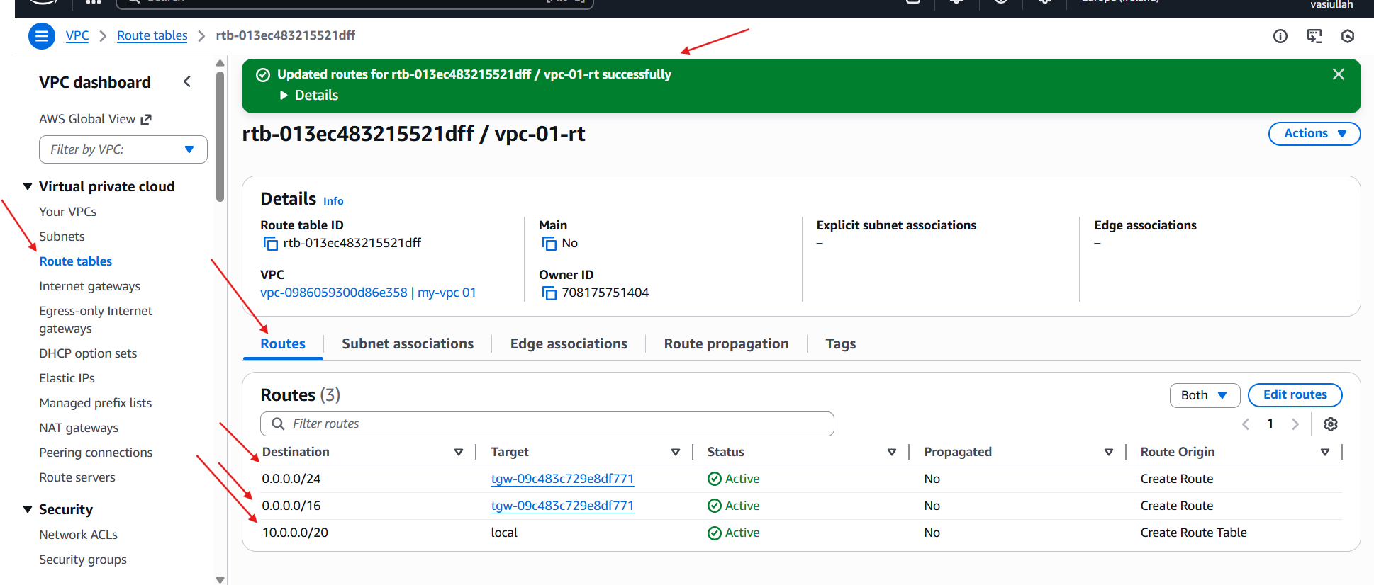
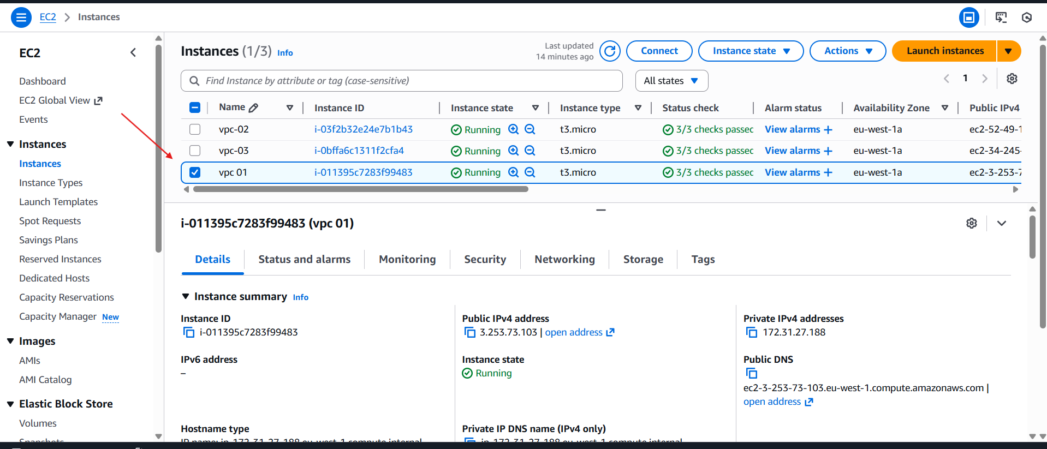
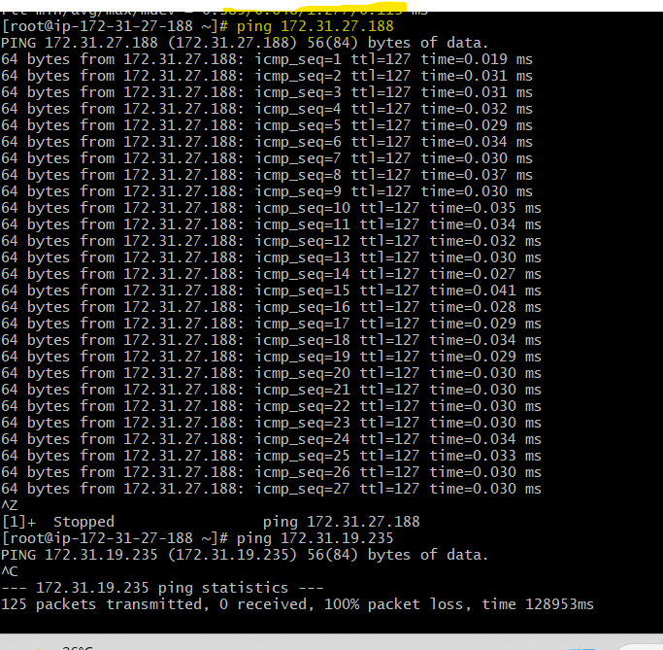
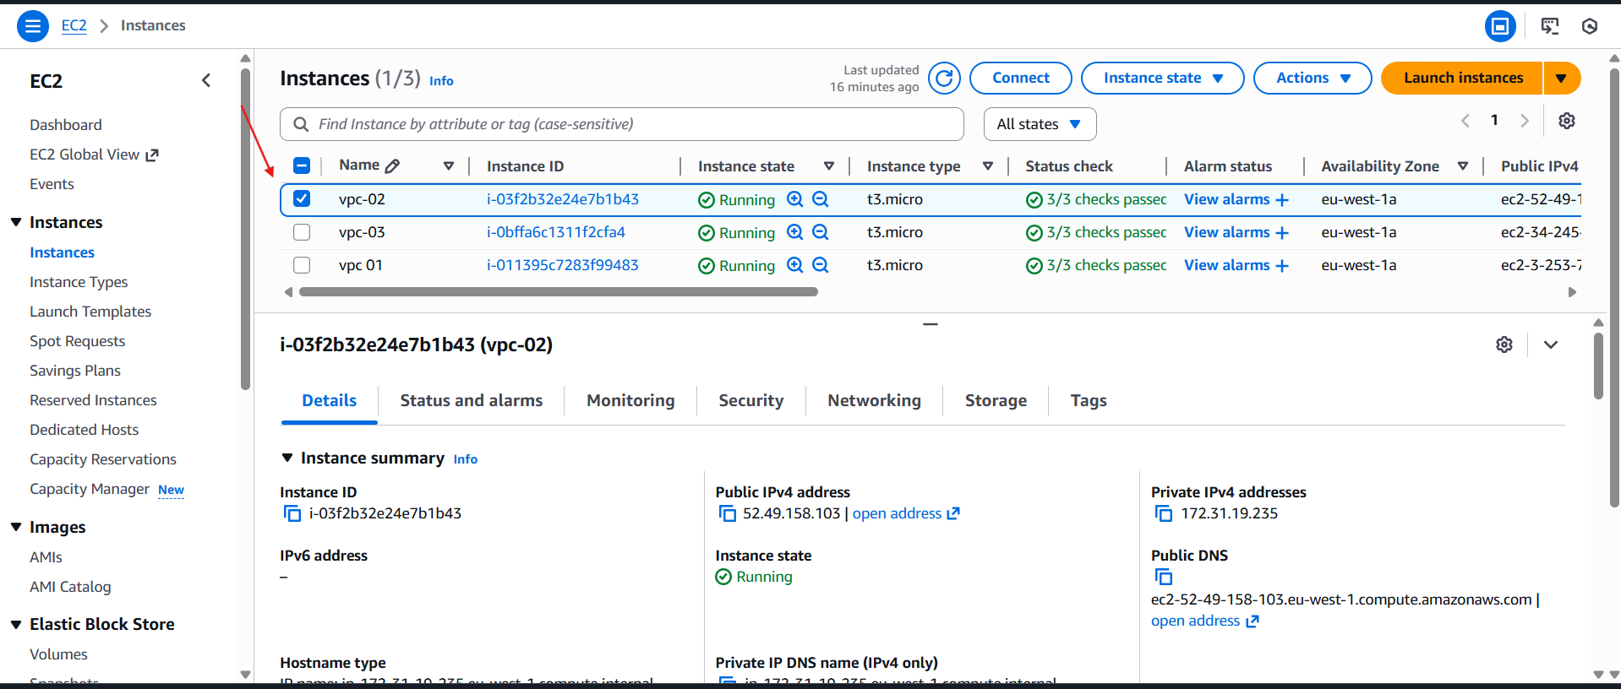
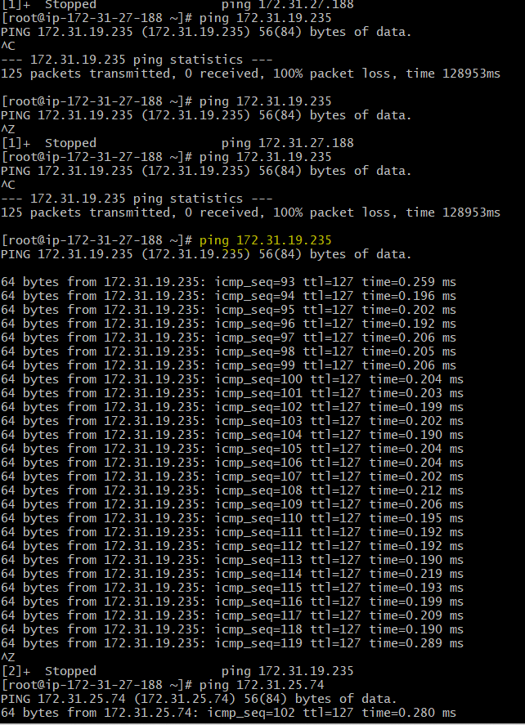
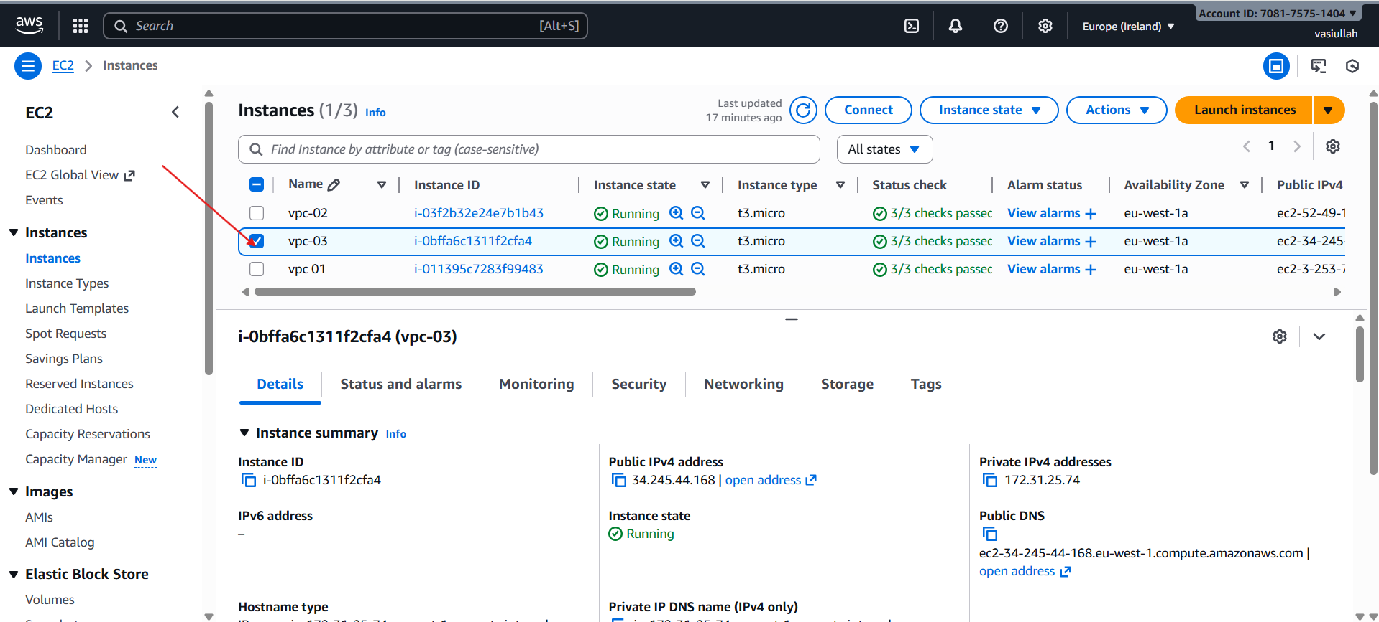
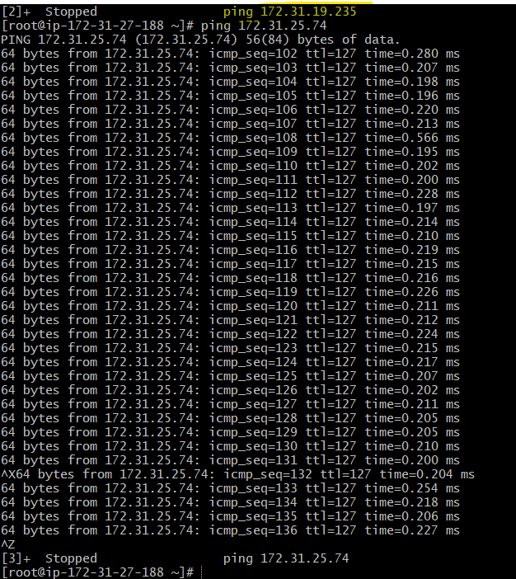

- Configure VPC endpoints to securely access AWS services without internet gateways or NAT gateways, ensuring data privacy and minimizing exposure to external threats.

- Create S3 Bucket
- AWS Management Console → S3 → Create bucket
- Fill in:
- Field | - Value
- Region | - Europe (Stockholm) eu-north-1
- Bucket type | - General purpose
- Bucket name | - my-s3-bucket-mujju
- Block Public Access | - Enabled (default recommended)
- Click Create bucket
- S3 bucket successfully created
- Create AWS Access Key
- IAM → Security credentials → Create access key (root/ IAM user)
- You generated:
- Access Key ID
- Secret Access Key
- download the .csv file
- Configure AWS CLI on EC2 Instance
- SSH into EC2:
- ssh -i "linux-sample.pem" ec2-user@<EC2-Public-IP>
- Run AWS configure:
- aws configure
- Enter the credentials:
- AWS Access Key ID: <your-access-key>
- AWS Secret Access Key: <your-secret-key>
- Default region: eu-north-1
- Default output format: json
- Verify S3 access:
- aws s3 ls
- Bucket visible
- Create VPC S3 Endpoint
VPC Console → Endpoints → Create endpoint
- Endpoint name: my-endpoint
Service category: AWS services
Search for S3 service:
com.amazonaws.eu-north-1.s3
- Select Type: Gateway
- Choose VPC:
vpc-068d558547ab00f25 (my-vpc-01)
- Select Route Tables:
private-rt
public-rt
Policy: Full access (default)
Click Create endpoint
Endpoint created successfully

- Test Private Access to S3 (No Internet Required)
From private subnet instance or same EC2:
aws s3 ls
Success again
This confirms:
S3 is reachable privately
EC2 uses VPC Endpoint, not the Internet
